

**ElectroGrid (EG) Project**

**Batch Group Y3.S1.WD.IT.01.01**

**Assignment Group 62**

|  |  |
| --- | --- |
| Registration No | Name |
| IT20145934 | Wanasooriya W.M.D.C. |
| IT20143886 | Samarawickrama H.N. |
| IT20146474 | Liyanage A.L.D.K.S |
| IT20154912 | Sahan A.K |
|  |  |

**Group work**

1. **Member details and role**

|  |  |  |  |
| --- | --- | --- | --- |
| **Student ID** | **Name** | **Web service** | **Description** |
| IT20145934 | Wanasooriya W.M.D.C. | Payment Management | * Add a Payment Details * View all Payment Details * Update the Payment Details * Delete a Payment Details |
| IT20143886 | Samarawickrama H.N. | Employee Management | * Add an Employee Details * View all Employee Details * Update the Employee Details * Delete an Employee Details |
| IT20146474 | Liyanage A.L.D.K.S | Registration Management | * Add a Registration Details * View all Registration Details * Update the Registration Details * Delete a Registration Details |
| IT20154912 | Sahan A.K | Billing Management | * Add a Billing Details * View all Billing Details * Update the Billing Details * Delete a Billing Details |

1. **Requirements Analysis (Functional, Non-functional, Technical requirements)**

|  |  |  |  |
| --- | --- | --- | --- |
| **Micro-service** | **Functional Requirement** | **Non-Functional Requirement** | **Technical Requirement** |
| Payment Management | * Add a Payment Details * View all Payment Details * Update the Payment Details * Delete a Payment Details | * Security and Privacy * Performance * Response in time * Maintainability * Data Integrity | After confirming the relevant payment, Customer can add payment details such as payment method(visa/master), card details (card number, name on card, CVC, expire date), bill amount to go ahead with procedure. System will make sure to validate payment details by avoiding null values and inaccurate data formats. Consumer can view all his/her payment details by payment id. Admin can manage payment details by updating payment details and deleting unnecessary payment details of the system. Payment details will be saved after payment get authorized. |
| Employee Management | * Add an Employee Details * View all Employee Details * Update the Employee Details * Delete an Employee Details | * Security and privacy * Scalability * High performance | The administrator can enter employee details. Each employee has a uniquely identifiable identity number. The administrator can view, update, delete and enter details about an employee. Only the administrator can perform the details entry, update, and deletion operations. |
| Registration Management | * Add a Registration Details * View all Registration Details * Update the Registration Details * Delete a Registration Details | * Security and privacy * Scalability * High performance * Recoverability * Availability | There are mainly 3 types of users in the system. Customer, admin, and manager. To check the bill balance, monthly electricity usage, overdue payment information through the system Customer must be registered to the system by the admin. When registering to the system as a valid Customer should provide name, address, email, phone number. The administrator of the system will check the details and accept their registering request. After that they can login to the system by providing valid credentials and check their electricity usage and do payments. As same the Customer, the manager also must register to the system to calculate bills, accept payments, and manage overdue information. The managers are added by the administrator of the system. Moreover, the administrator of the system can search for users, update details of the users and remove inactive users from the system. |
| Billing Management | * Add a Billing Details * View all Billing Details * Update the Billing Details * Delete a Billing Details | * Security and privacy * Scalability * High performance | The administrator can enter the billing details to the system. Each bill has a unique bill id. If the administrator wants to update or delete bill details, he can do it through the billing management function. |

1. **Clickable link for GitHub Repository**

[**https://github.com/IT20146474/ElectroGrid-EG-G62.git**](https://github.com/IT20146474/ElectroGrid-EG-G62.git)

1. **SE Methodology/Methods - Agile Software Development**

What is Agile?

Agile Software Development is a methodology for creating a disciplined software management process that also allows for rapid changes to the development project. This methodology reduces risk by building software in short time periods known as iterations, which typically run one week to one month.

|  |  |
| --- | --- |
| Advantages of Agile development methodology | Disadvantages of Agile Development Methodology |
| This methodology has an adaptive approach which is able to respond to the changing requirements of the clients and etc. | This methodology focuses on working software rather than documentation, hence it may result in a lack of documentation and etc. |

How we organized as a team to work with Agile methodology?

After talks (modify the requirements or accept the team's proposals), the scope of work was occasionally altered to accommodate new requirements. This is referred to as Agile's flexibility advantage. We divided the scenario's requirements into five micro services after recognizing them. This is another benefit of using Agile approach, which allows you to divide down work and consider microservices as tiny cycles (known as Sprints in Scrum). Because of the discussions with team members, they work closely together and have a clear understanding of their roles, and the work done within a cycle is frequently reassessed to improve the final result.

1. **Time Link (Gantt Chart)**

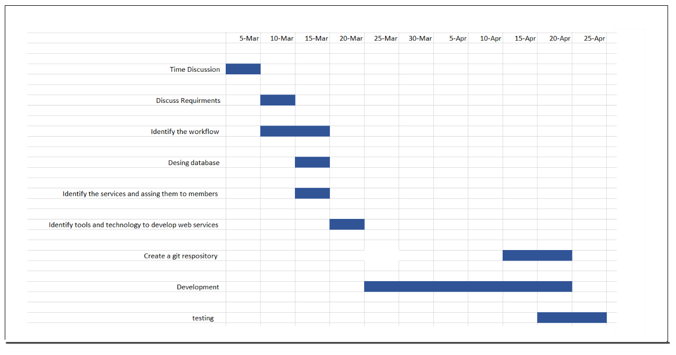

1. **Stakeholder Analysis**

Onion Diagram

**ElectroGrid (EG) Application**



Tester

Developer

Business Analyst

User

System Administaror

Executive

HR Manager

Financial Manager

1. **Overall Use Case Diagram**

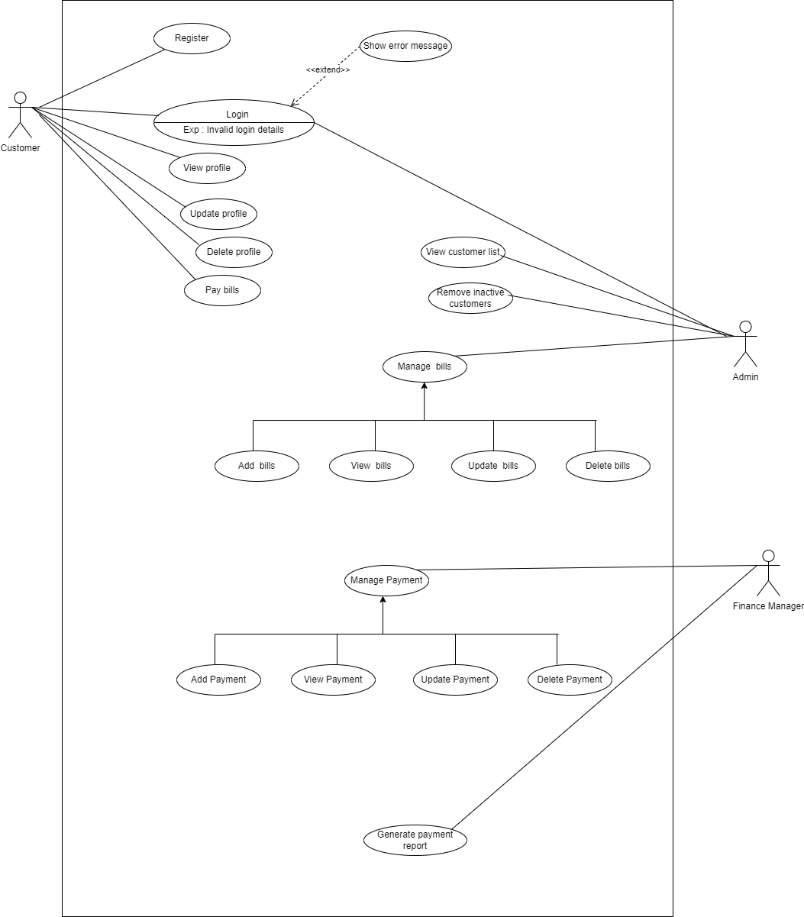

1. **Overall Activity Diagram**

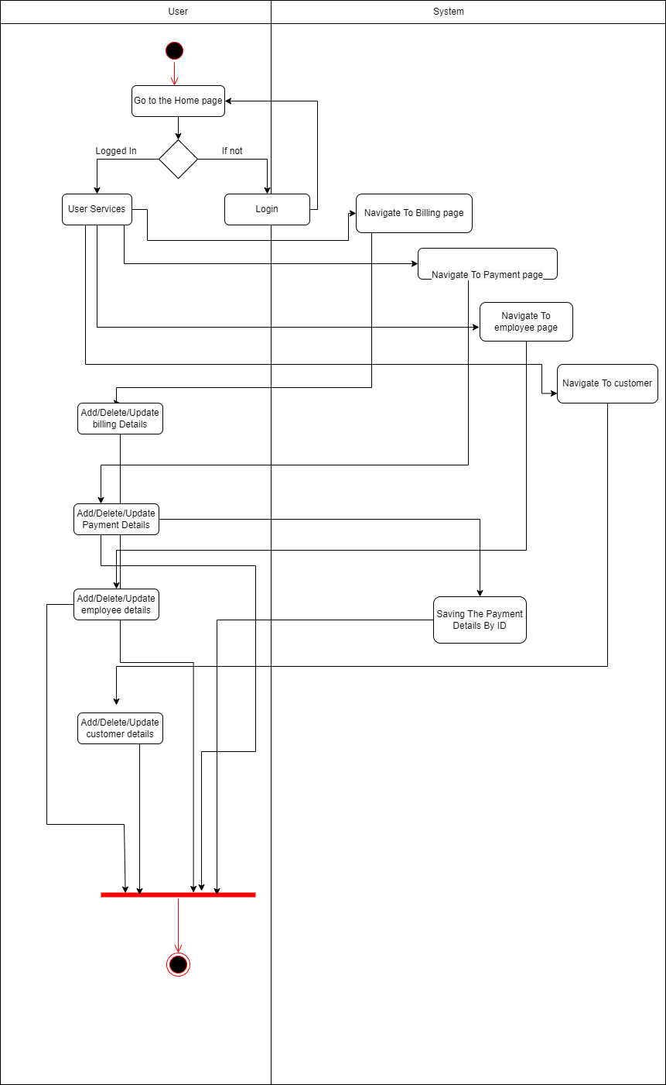

1. **Overall ER Diagram**

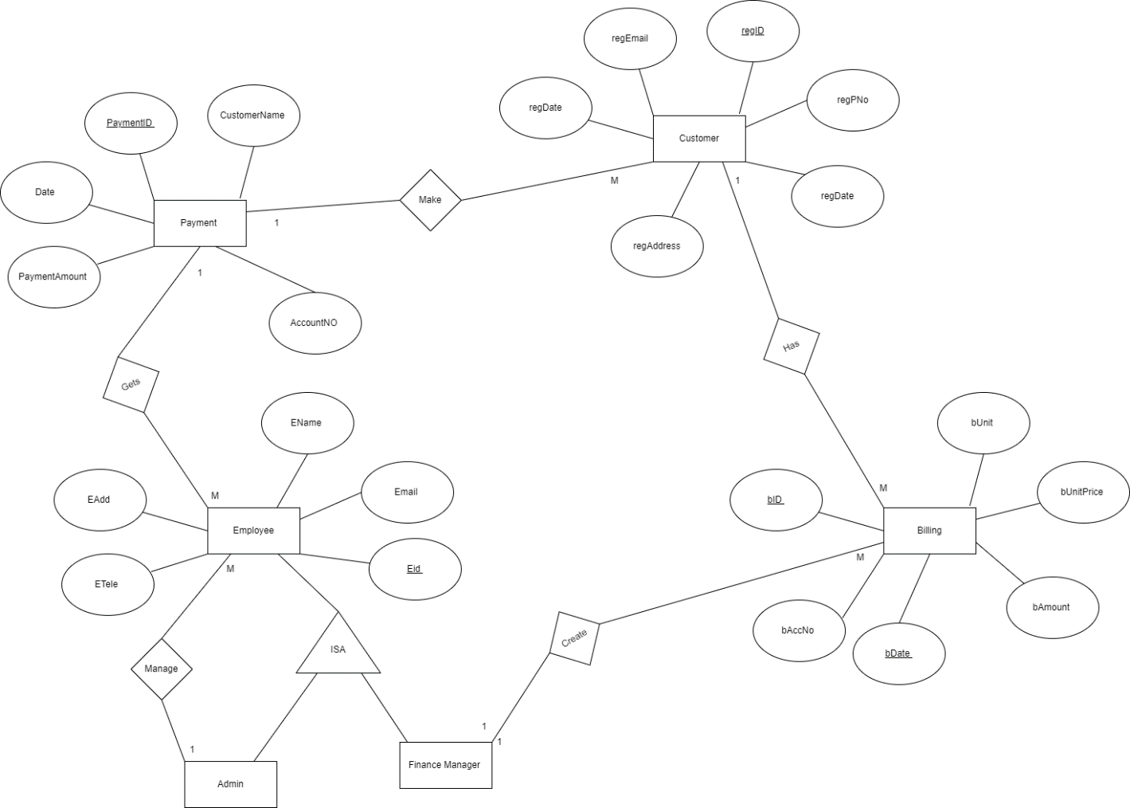

1. **Overall, Class Diagram**

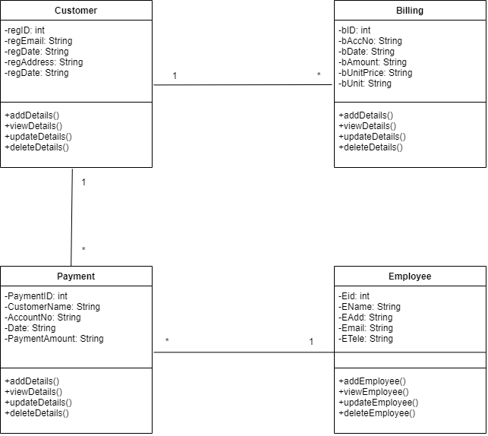

1. **Overall Data Base**

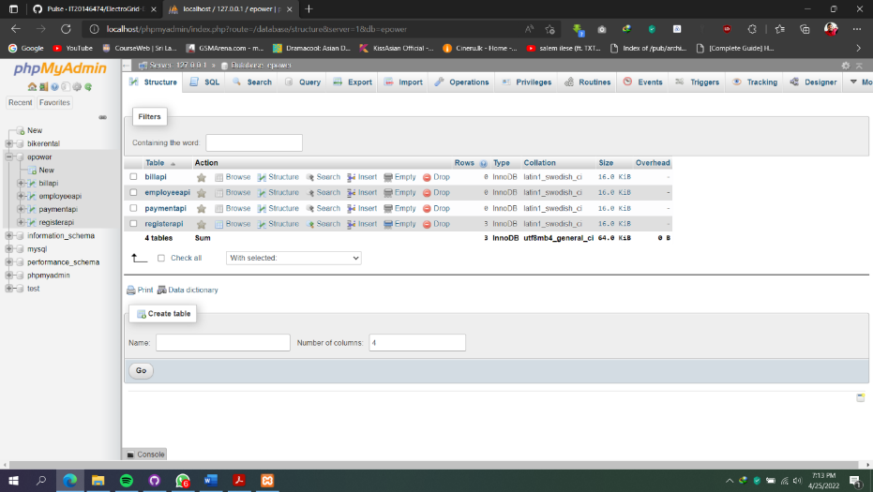

1. **Individual Section**

**IT20145934**

**Wanasooriya W.M.D.C.**

1. **API design: Payment Management**

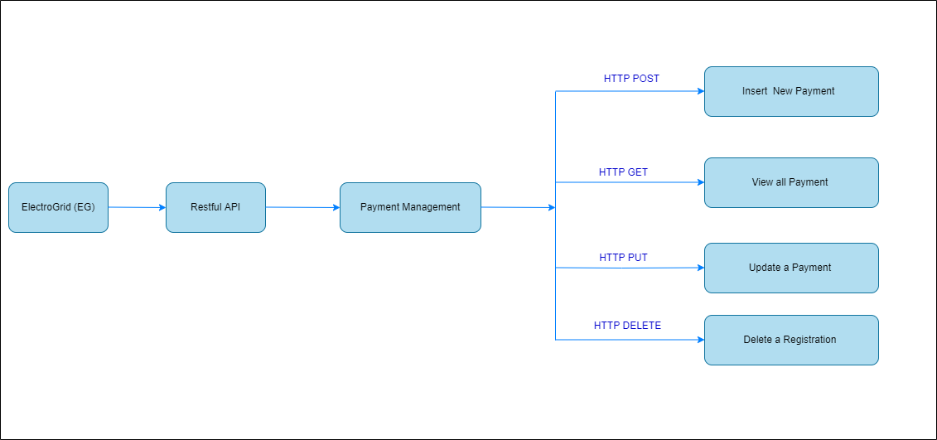

|  |  |
| --- | --- |
| **Resource** | Payment |
| **Request** | GET Payment_Management/ Payment API/ Payment (Get all Payment details) |
| **URL** | http://localhost:8085/Registration_Management/RegistrationAPI/Registration |

|  |  |
| --- | --- |
| **Resource** | Payment |
| **Request** | POST Payment_Management/ Payment API/ Payment (Insert Payment details) |
| **URL** | http://localhost:8085/Registration_Management/RegistrationAPI/Registration |

|  |  |
| --- | --- |
| **Resource** | Payment |
| **Request** | PUT Payment_Management/ Payment API/ Payment (Update Payment details) |
| **URL** | http://localhost:8085/Registration_Management/RegistrationAPI/Registration |

|  |  |
| --- | --- |
| **Resource** | Payment |
| **Request** | DELETE Payment_Management/ Payment API/ Payment (Delete Registration details) (Delete Payment by ID) |
| **URL** | http://localhost:8085/Registration_Management/RegistrationAPI/Registration |

**2.Internal logic design**

* Class Diagram

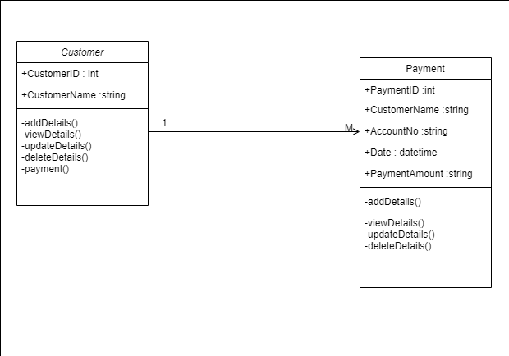

* Flow Chart Diagrams

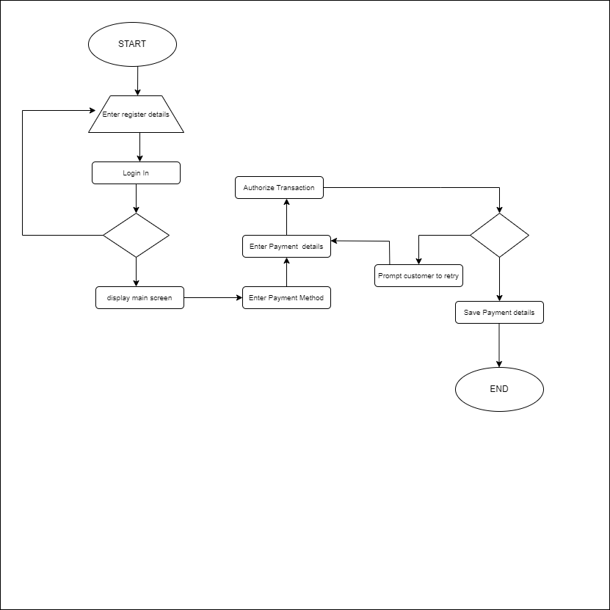

**3. Any other relevant design diagrams**

* Activity Diagram

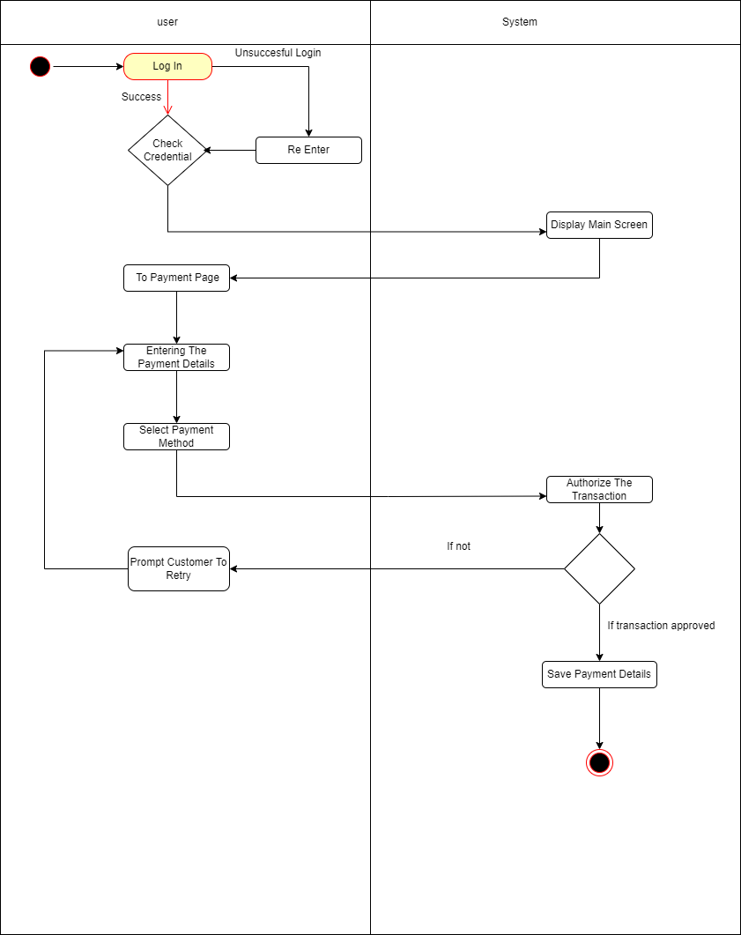

* User case Diagrams

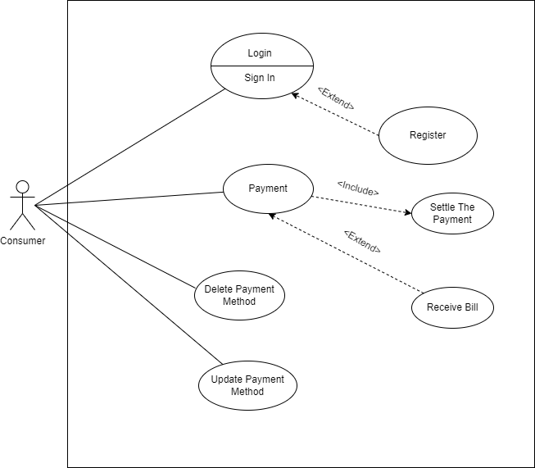

* Er Diagram

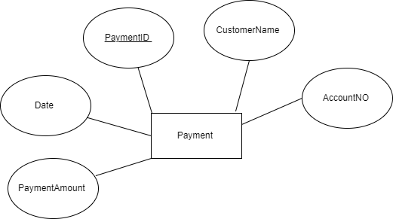

**4. Data Base**

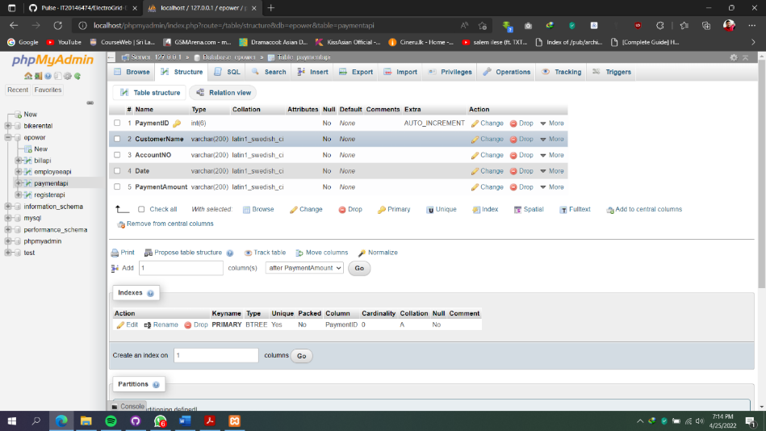

**5.Development tools selection and justification.**

Tools used

* + Dependency Management Tool: - Maven
  + Testing Tool: - Postman
  + IDE: - Eclipse
  + Programming Language: Java
  + Framework: - JAX - RS
  + Database: - phpMyAdmin (MySQL)
  + Server: - Apache Tomcat
  + Version Control System: - Git

**6.Testing methodology and results.**

|  |  |  |  |  |  |
| --- | --- | --- | --- | --- | --- |
| **Test ID** | **Test Description** | **Test Input(s)** | **Expected Output** | **Actual Output** | **Result**  **(Pass/Fail)** |
| 01) | Add a payment | Attributes of payment | Saves into the database  and display message  " Insert successfully" | Saves into the database  and get message  "Insert added successfully" | pass |
| 02) | Update payment Details | Attributes to be updated along with the Payment ID | Display message as " updated successfully" | Display message as " updated successfully" | Pass |
| 03) | View payment details by Payment ID | URL for the API and Payment ID | Display payment details | Display payment details | Pass |
| 04) | Delete Payment by id | Payment ID of the Payment want to delete | Display message as  "Deleted successfully" | Display message as  "Deleted successfully" | Pass |

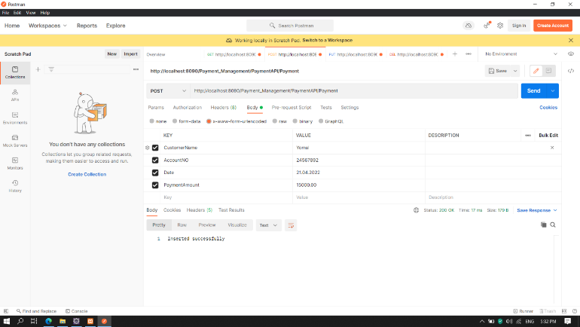

Add a payment

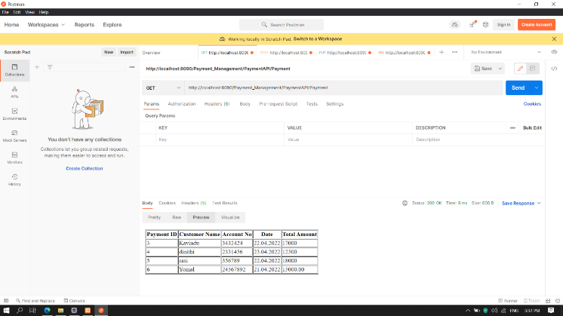

After Insert Payment Details

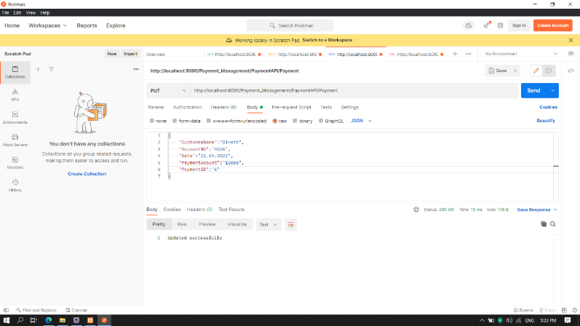

Update payment Details

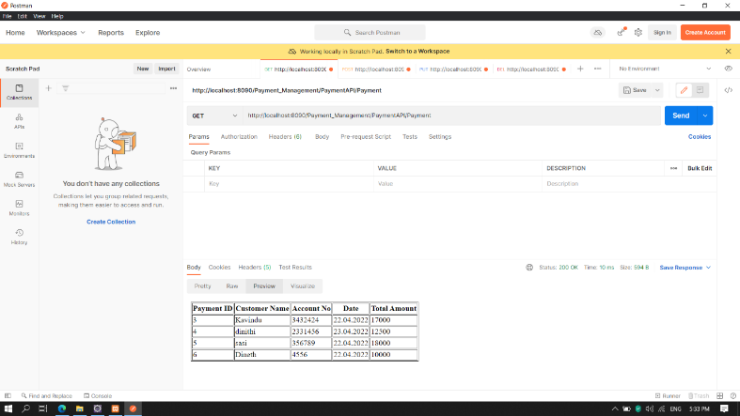

After Update Payment Details

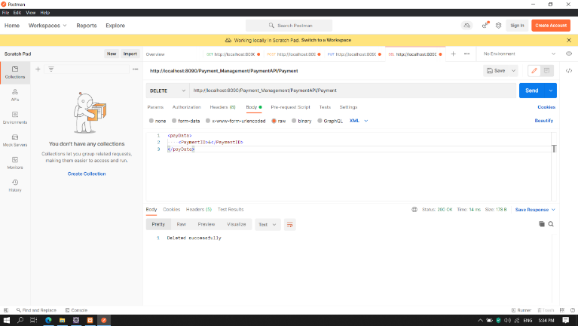

Delete Payment using PaymentID

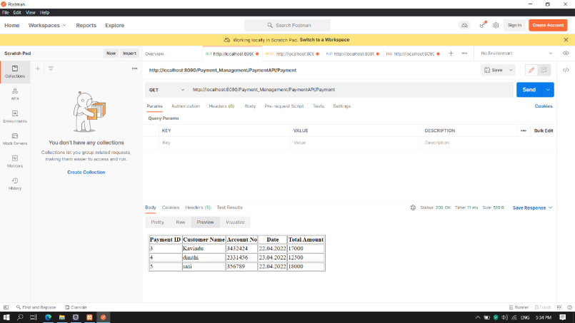

After Delete Payment Details (Delete Payment ID 6)

**IT20143886**

**Samarawickrama H.N.**

1. **API design: Employee Management**

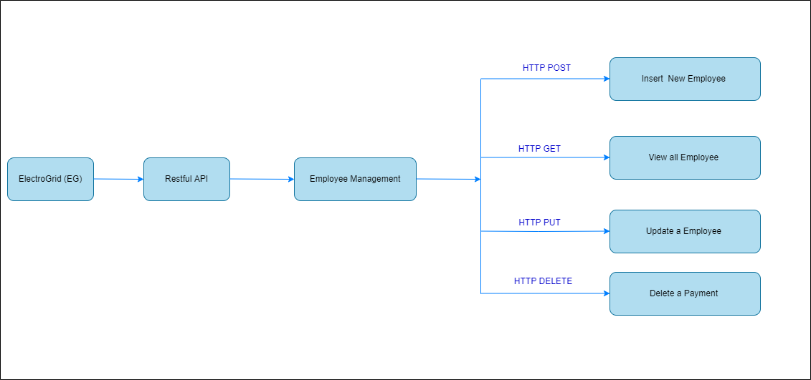

|  |  |
| --- | --- |
| **Resource** | Employee |
| **Request** | GET Employee_Management /EmployeeAPI/ Employee (Get all Registration details) |
| **URL** | http://localhost:8080/Employee_Management/EmployeeAPI/Employee |

|  |  |
| --- | --- |
| **Resource** | Employee |
| **Request** | POST Employee_Management /EmployeeAPI/ Employee (Insert Registration details) |
| **URL** | http://localhost:8080/Employee_Management/EmployeeAPI/Employee |

|  |  |
| --- | --- |
| **Resource** | Employee |
| **Request** | PUT Employee_Management /EmployeeAPI/ Employee (Update Registration details) |
| **URL** | http://localhost:8080/Employee_Management/EmployeeAPI/Employee |

|  |  |
| --- | --- |
| **Resource** | Employee |
| **Request** | DELETE Employee_Management /EmployeeAPI/ Employee (Delete Registration details) (Delete Registration by ID) |
| **URL** | http://localhost:8080/Employee_Management/EmployeeAPI/Employee |

**2.Internal logic design**

* Class Diagram

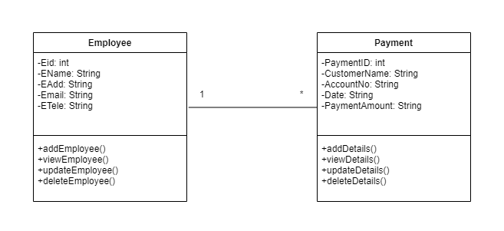

* Flow Chart Diagrams

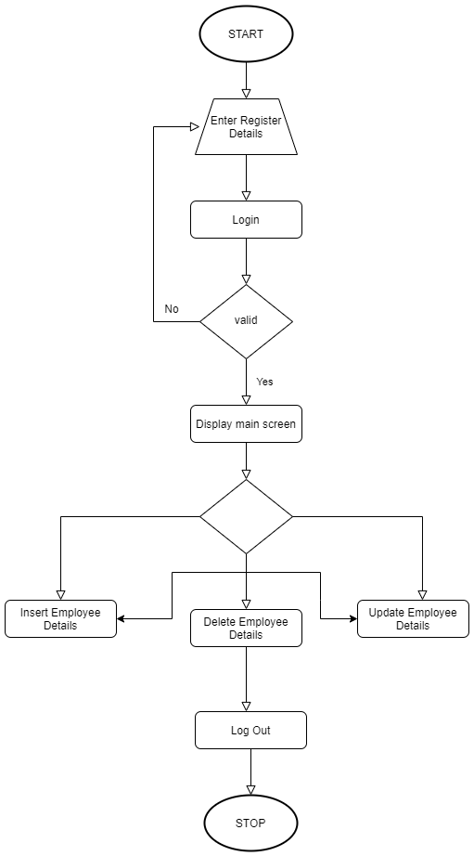

**3. Any other relevant design diagrams**

Activity Diagram (Funding Service)

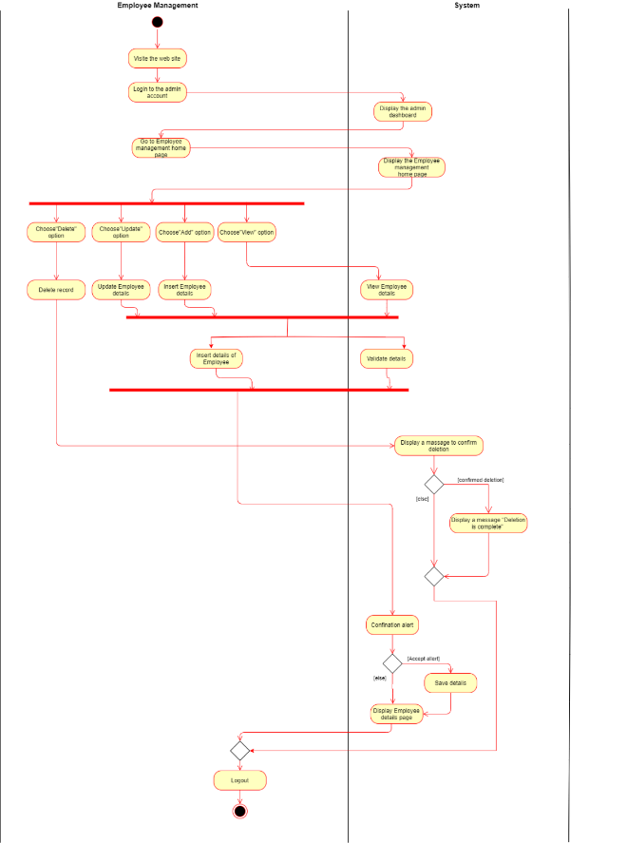

* User case Diagrams

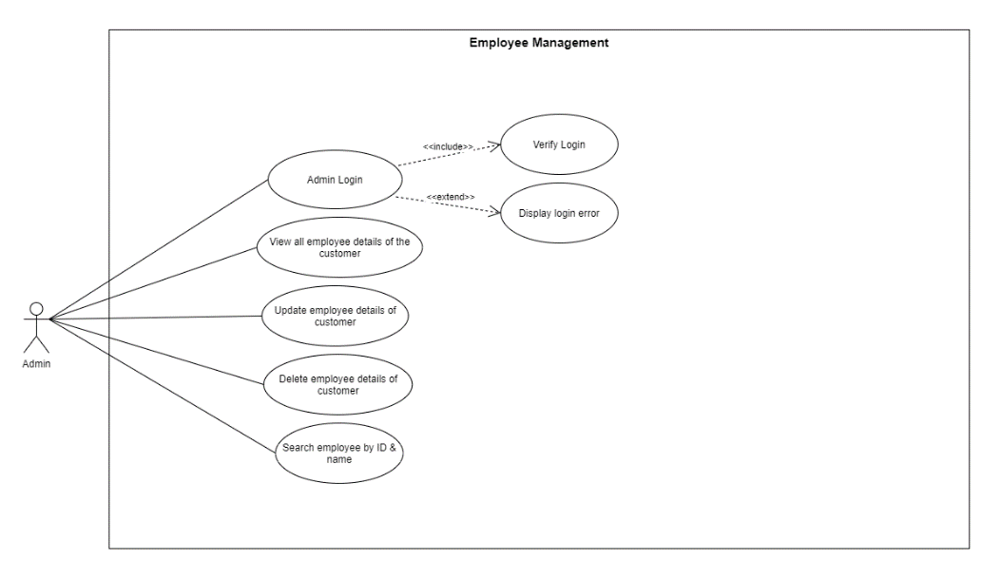

**4.Data Base**

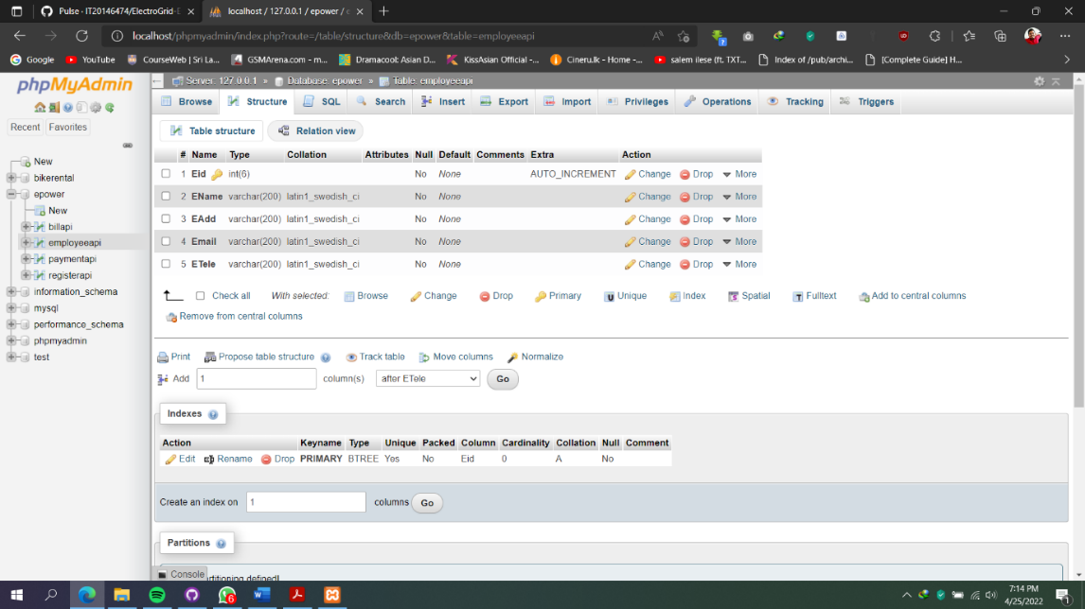

**5.Development tools selection and justification.**

Tools used

* + Dependency Management Tool: - Maven
  + Testing Tool: - Postman
  + IDE: - Eclipse
  + Programming Language: Java
  + Framework: - JAX - RS
  + Database: - phpMyAdmin (MySQL)
  + Server: - Apache Tomcat
  + Version Control System: - Git

**6.Testing methodology and results.**

|  |  |  |  |  |  |
| --- | --- | --- | --- | --- | --- |
| **Test ID** | **Test Description** | **Test Input(s)** | **Expected Output** | **Actual Output** | **Result**  **(Pass/Fail)** |
| 01) | Add an Employee  Details | Attributes of Employee | Saves into the database  and display message  " Insert successfully" | Saves into the database  and get message  "Insert added successfully" | pass |
| 02) | Update Employee Details | Attributes to be updated along with the Employee ID | Display message as " updated successfully" | Display message as " updated successfully" | Pass |
| 03) | View Employee details by Employee ID | URL for the API and Employee ID | Display Employee details | Display payment details | Pass |
| 04) | Delete Employee by id | Employee ID of the Employee want to delete | Display message as  "Deleted successfully" | Display message as  "Deleted successfully" | Pass |

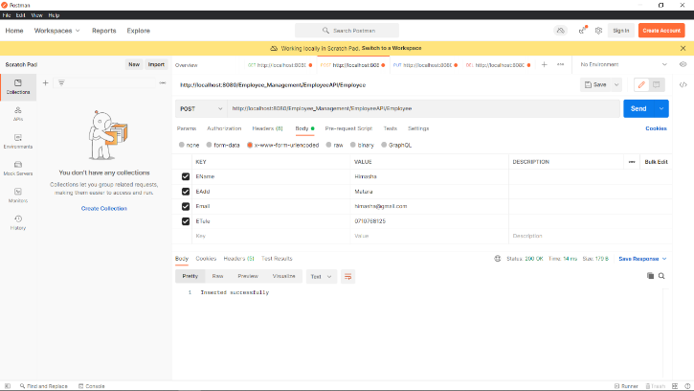

Add an Employee

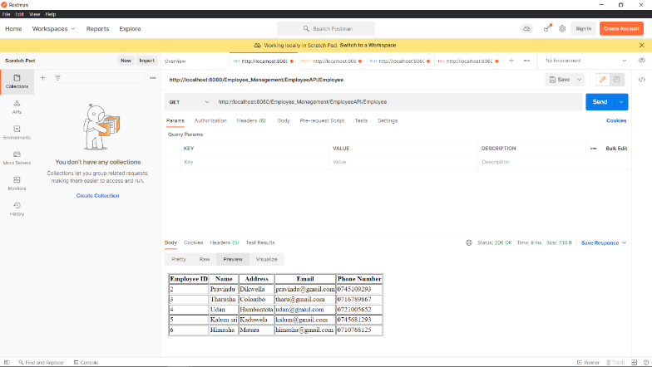

After Insert Employee Details

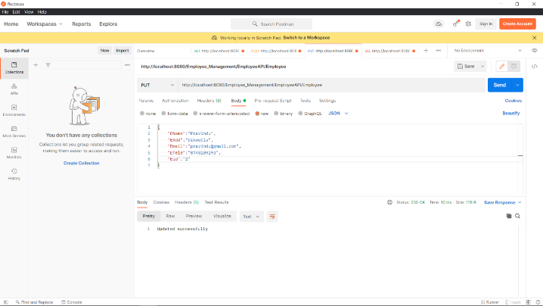

Update Employee Details

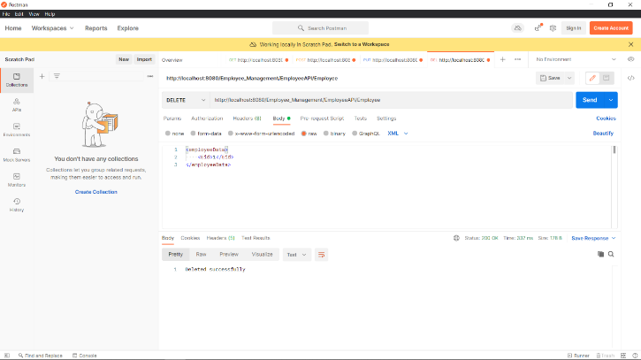

Delete Employee using EmployeeID

**IT20146474**

**Liyanage A.L.D.K.S**

1. **API Design: Registration Management**

|  |  |
| --- | --- |
| **Resource** | Registration |
| **Request** | GET Registration_Management/RegistrationAPI/Registration (Get all Registration details) |
| **URL** | http://localhost:8085/Registration_Management/RegistrationAPI/Registration |

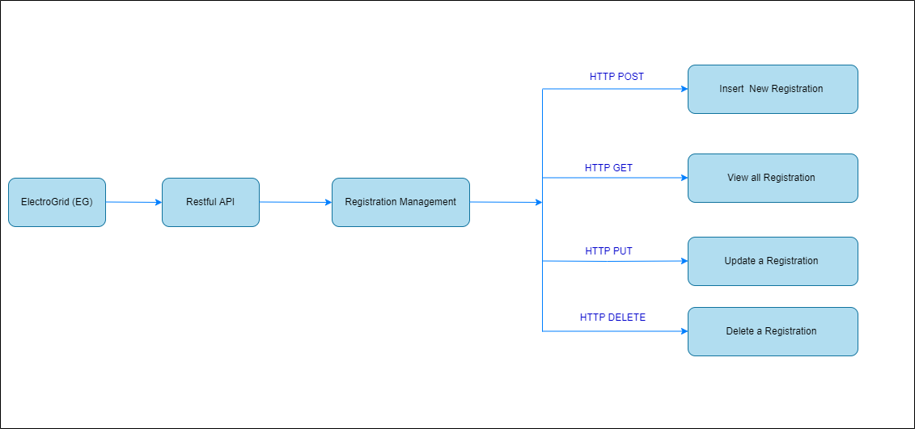

|  |  |
| --- | --- |
| **Resource** | Registration |
| **Request** | POST Registration_Management/RegistrationAPI/Registration (Insert Registration details) |
| **URL** | http://localhost:8085/Registration_Management/RegistrationAPI/Registration |

|  |  |
| --- | --- |
| **Resource** | Registration |
| **Request** | PUT Registration_Management/RegistrationAPI/Registration (Update Registration details) |
| **URL** | http://localhost:8085/Registration_Management/RegistrationAPI/Registration |

|  |  |
| --- | --- |
| **Resource** | Registration |
| **Request** | DELETE Registration_Management/RegistrationAPI/Registration (Delete Registration details) (Delete Registration by ID) |
| **URL** | http://localhost:8085/Registration_Management/RegistrationAPI/Registration |

**2.Internal logic design**

* Class Diagram

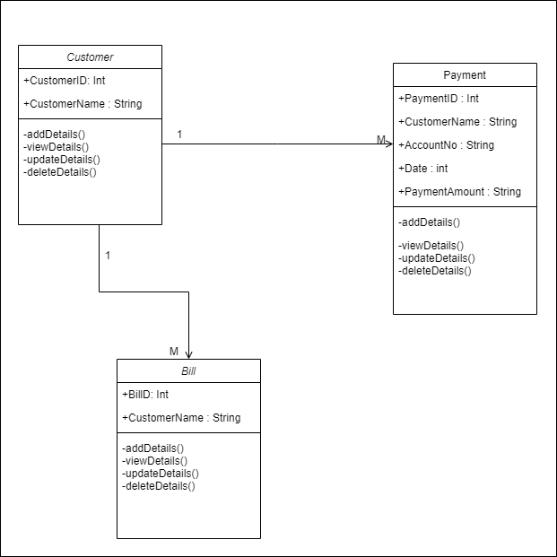

* Flow Chart Diagrams

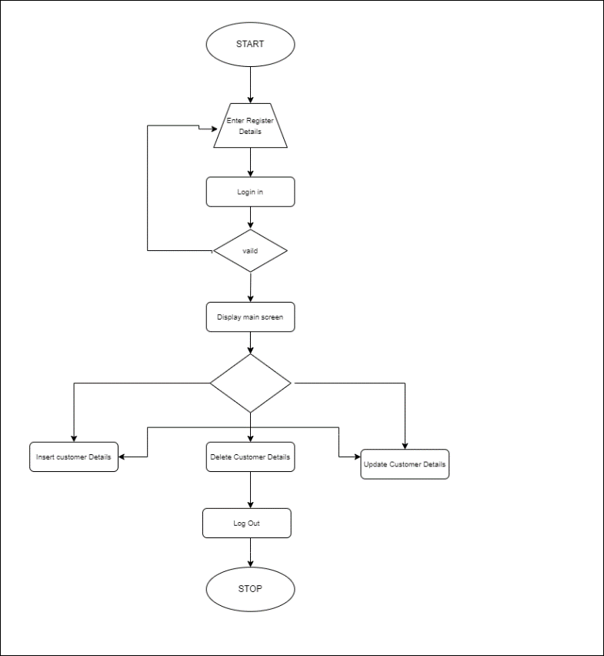

**3. Any other relevant design diagrams**

* Activity Diagram (Funding Service)

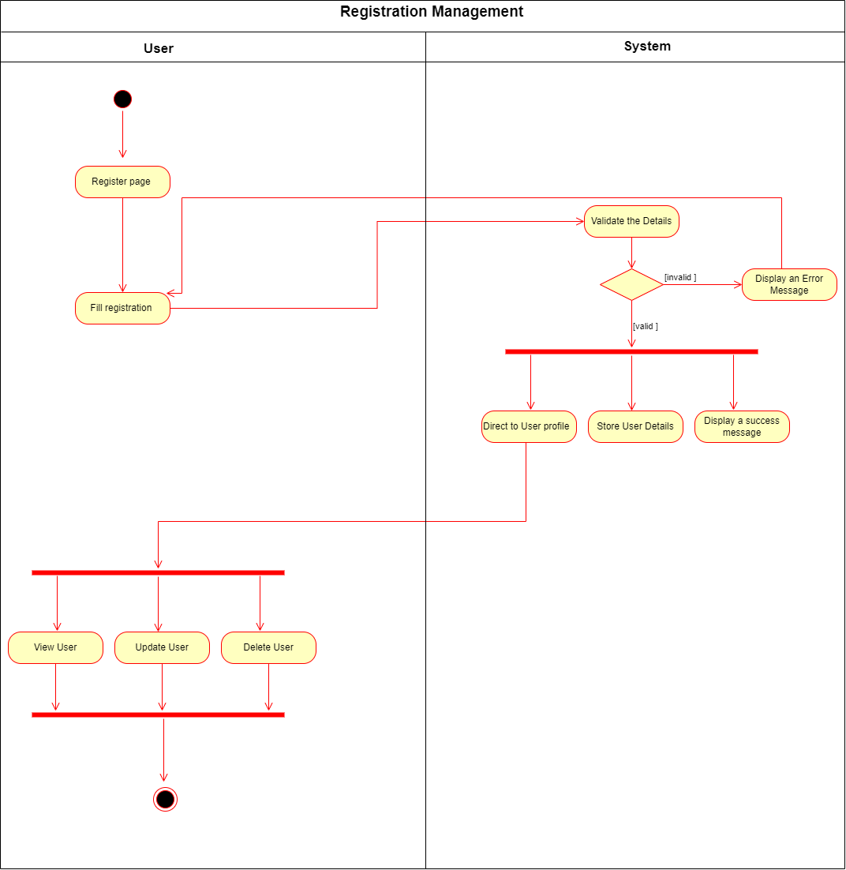

* User case Diagrams 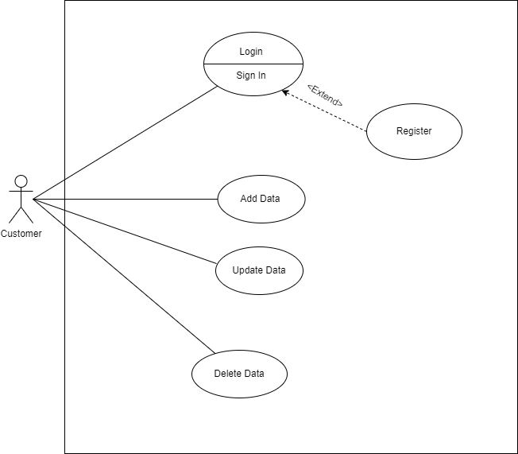
* Er Diagram

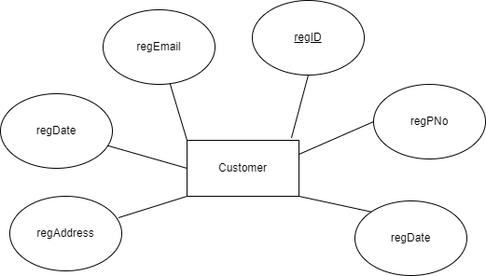

**4.Data Base**

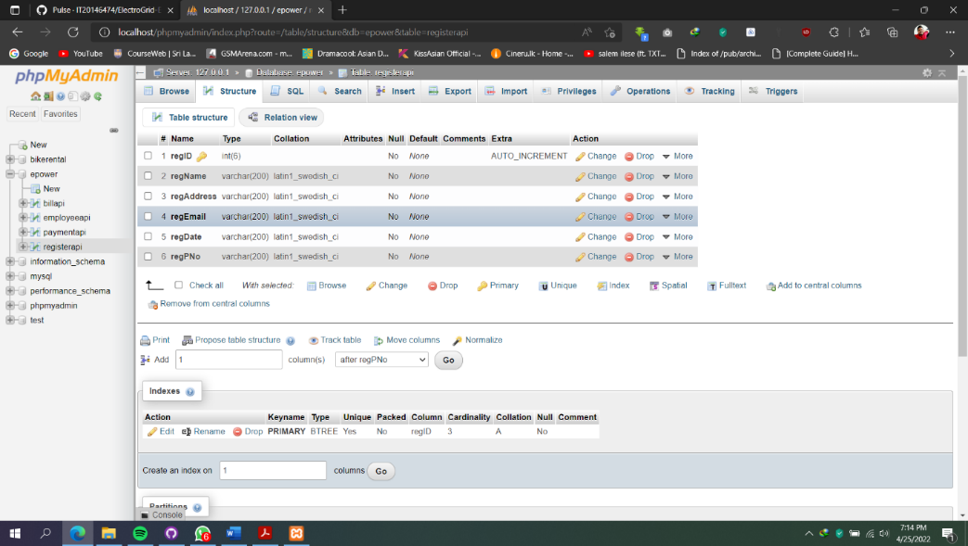

**5.Development tools selection and justification.**

Tools used

* + Dependency Management Tool: - Maven
  + Testing Tool: - Postman
  + IDE: - Eclipse
  + Programming Language: Java
  + Framework: - JAX - RS
  + Database5: - phpMyAdmin (MySQL)
  + Server: - Apache Tomcat
  + Version Control System: - Git

**6.Testing methodology and results.**

|  |  |  |  |  |  |
| --- | --- | --- | --- | --- | --- |
| **Test ID** | **Test Description** | **Test Input(s)** | **Expected Output** | **Actual Output** | **Result**  **(Pass/Fail)** |
| 01) | Add Register Details | Attributes of Register | Saves into the database  and display message  " Insert successfully" | Saves into the database  and get message  "Insert added successfully" | pass |
| 02) | Update Register Details | Attributes to be updated along with the Register ID | Display message as " updated successfully" | Display message as " updated successfully" | Pass |
| 03) | View Register details by Register ID | URL for the API and Register ID | Display Register details | Display Register details | Pass |
| 04) | Delete Register by id | Register ID of the Register want to delete | Display message as  "Deleted successfully" | Display message as  "Deleted successfully" | Pass |

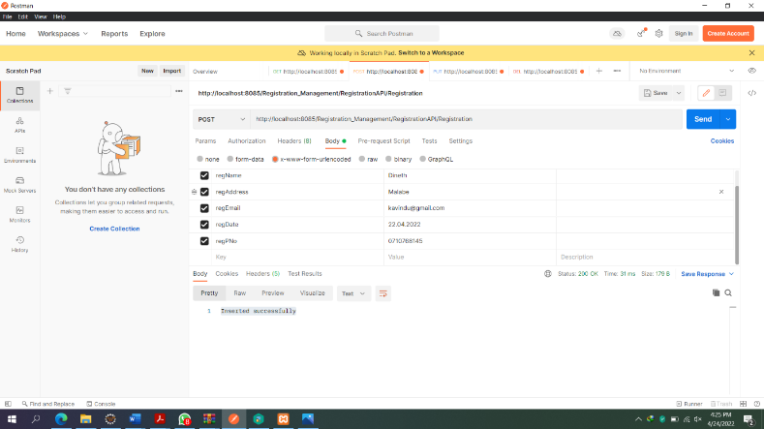

Add a Register Details

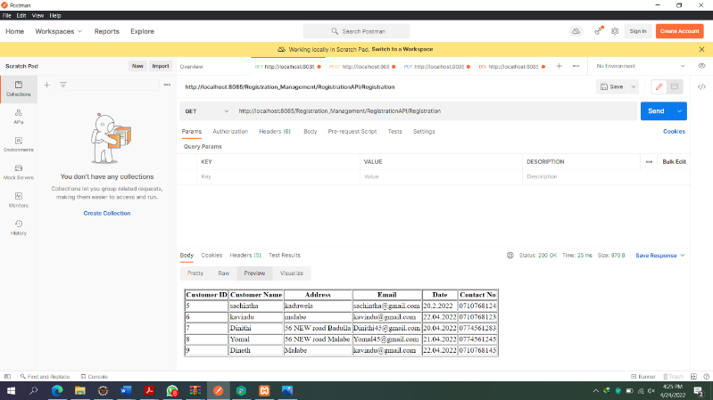

After Insert Register Details

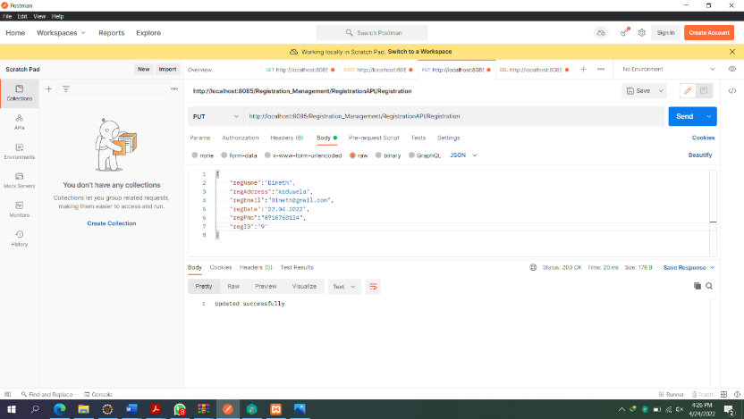

Update Register Details

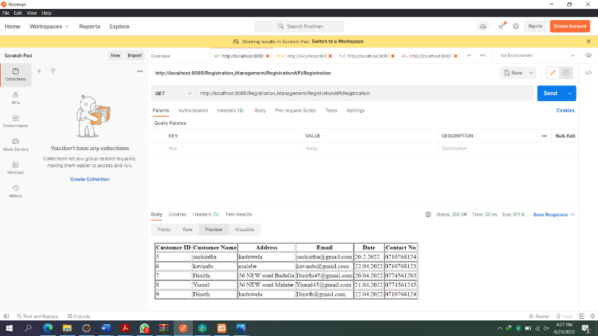

After Update Register Details (Update RegisterID 9)

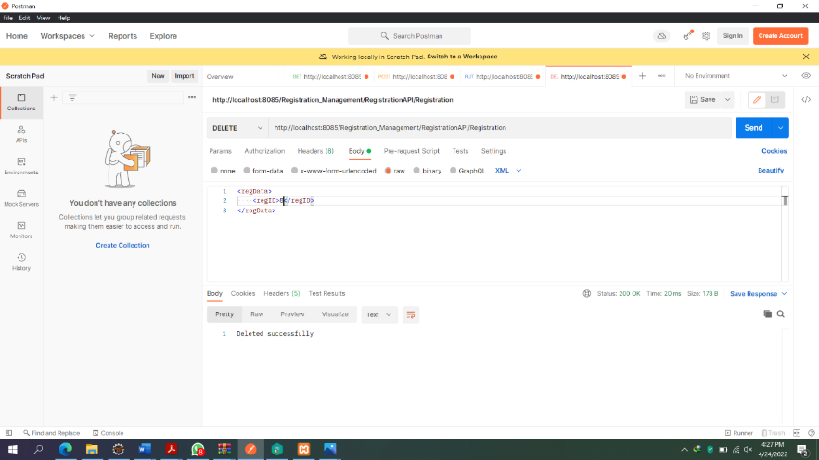

Delete Register using RegisterID

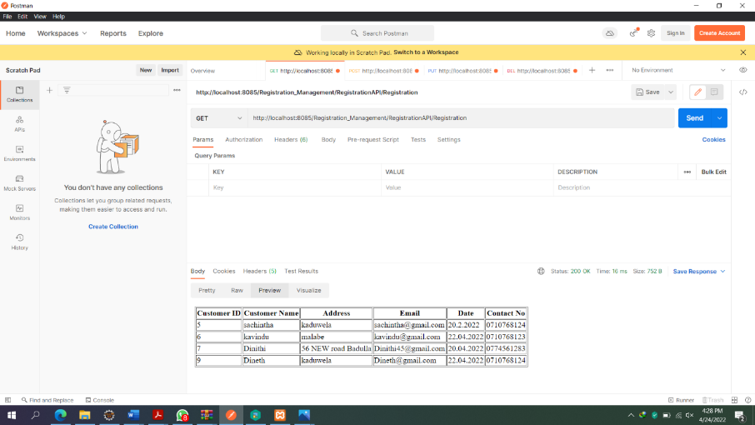

After Delete Register Details (Delete Register ID 8)

**IT20154912**

**Sahan A. K**

**1.API Design: Billing Management**

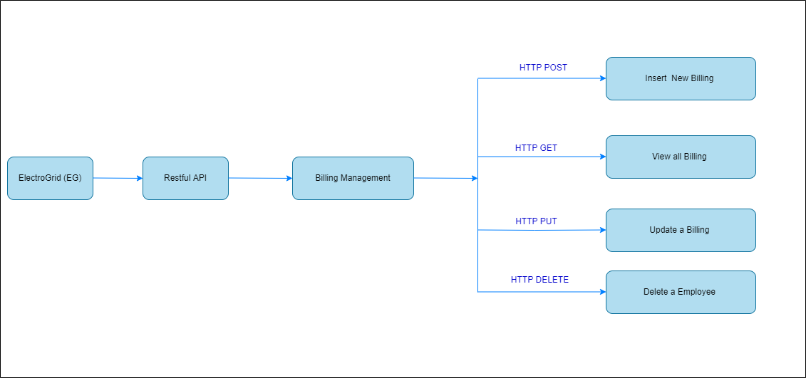

|  |  |
| --- | --- |
| **Resource** | Funds |
| **Request** | GET Billing_Management/BillingAPI/Billing |
| **URL** | http://localhost:8085/Billing_Management/BillingAPI/Billing |

|  |  |
| --- | --- |
| **Resource** | Funds |
| **Request** | GET Billing_Management/BillingAPI/Billing |
| **URL** | http://localhost:8085/Billing_Management/BillingAPI/Billing |

|  |  |
| --- | --- |
| **Resource** | Funds |
| **Request** | POST Billing_Management/BillingAPI/Billing |
| **URL** | http://localhost:8085/Billing_Management/BillingAPI/Billing |

|  |  |
| --- | --- |
| **Resource** | Funds |
| **Request** | PUT Billing_Management/BillingAPI/Billing |
| **URL** | http://localhost:8085/Billing_Management/BillingAPI/Billing |

**2.Internal logic design**

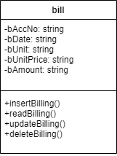

**3. Any other relevant design diagrams**

* Activity Diagram (Funding Service)

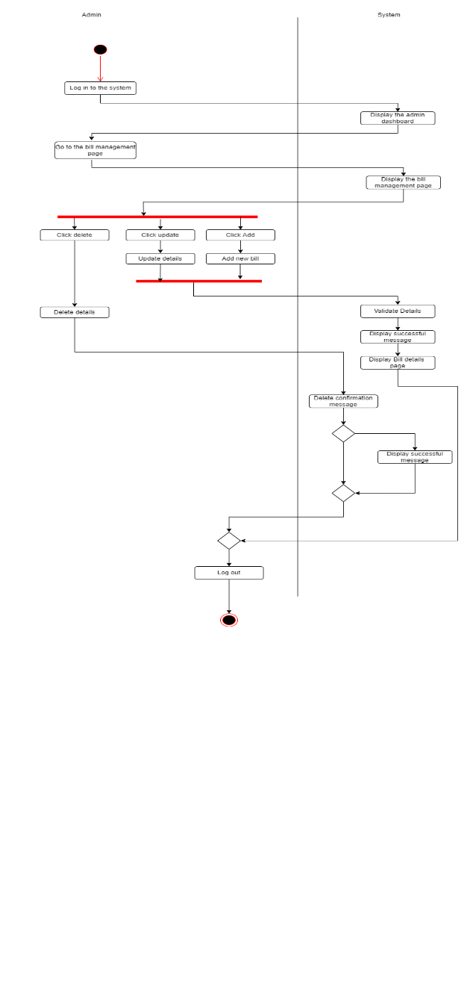

* User case Diagrams

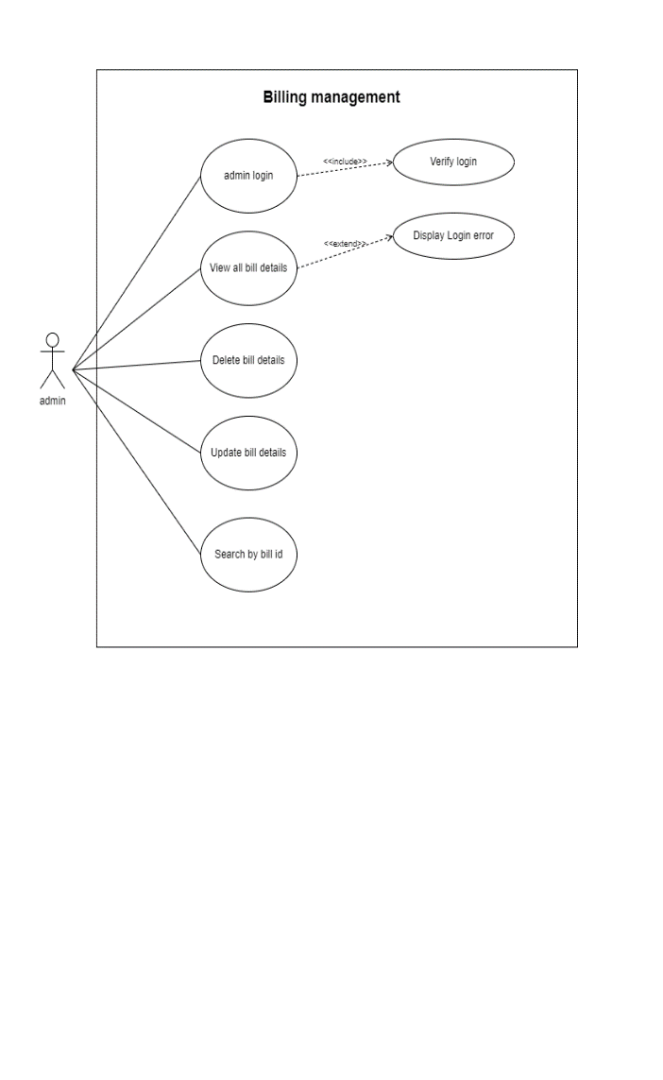

**4.Data Base**

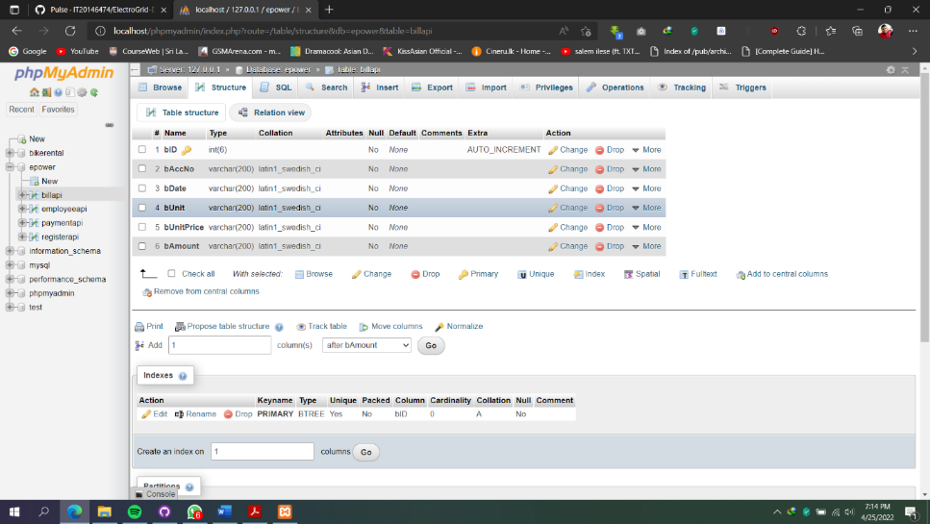

**5.Development tools selection and justification.**

Tools used

* + Dependency Management Tool: - Maven
  + Testing Tool: - Postman
  + IDE: - Eclipse
  + Programming Language: Java
  + Framework: - JAX - RS
  + Database: - phpMyAdmin (MySQL)
  + Server: - Apache Tomcat
  + Version Control System: - Git

|  |  |  |  |  |  |
| --- | --- | --- | --- | --- | --- |
| **Test ID** | **Test Description** | **Test Input(s)** | **Expected Output** | **Actual Output** | **Result**  **(Pass/Fail)** |
| 01) | Add Bill Details | Attributes of Bill | Saves into the database  and display message  " Insert successfully" | Saves into the database  and get message  "Insert added successfully" | pass |
| 02) | Update Bill Details | Attributes to be updated along with the Bill ID | Display message as " updated successfully" | Display message as " updated successfully" | Pass |
| 03) | View Bill details by Bill ID | URL for the API and Bill ID | Display Bill details | Display Bill details | Pass |
| 04) | Delete Bill by id | Bill ID of the Bill want to delete | Display message as  "Deleted successfully" | Display message as  "Deleted successfully" | Pass |

**6.Testing methodology and results.**

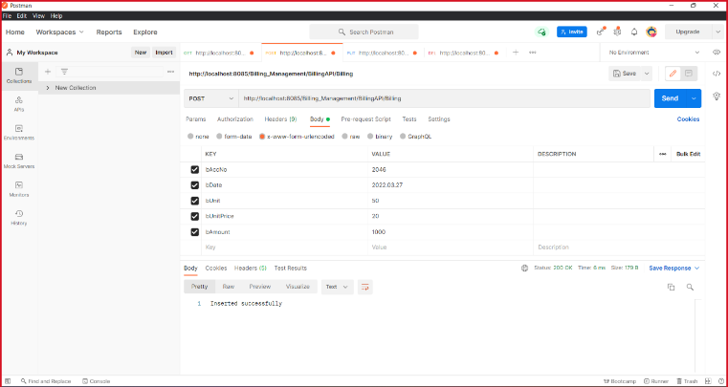

Add a Bill

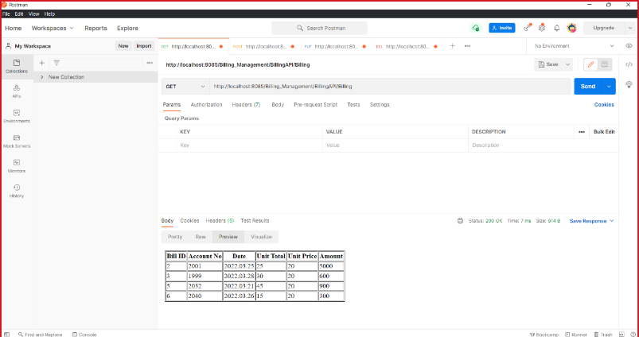

After Insert Bill Details

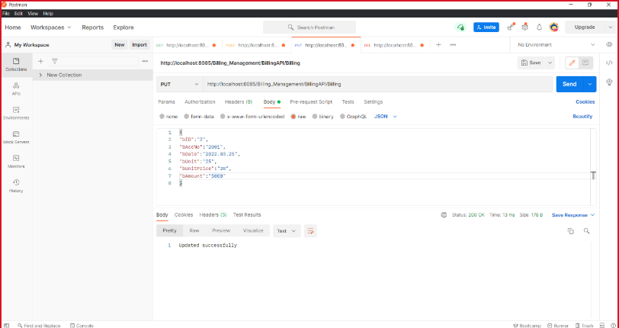

Update Bill Details

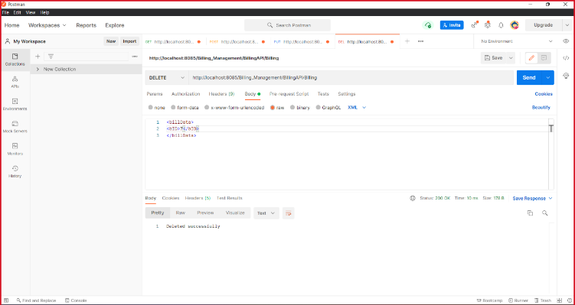

Delete Bill using BillID